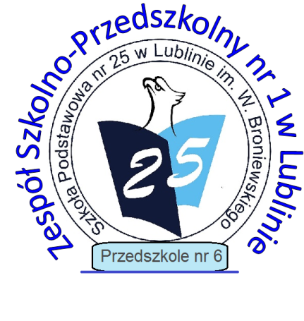
Zespół Szkolno-Przedszkolny nr 1 w Lublinie

20-089 Lublin, ul. Sieroca 17

tel. 81 7474849 fax. 81 7474849
e-mail: poczta@zsp1.lublin.euac

strona: www.sp25.lublin.eu
e-PUAP: /zsp1-lublin/SkrytkaESP

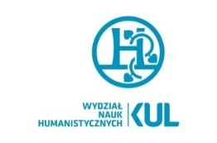
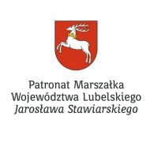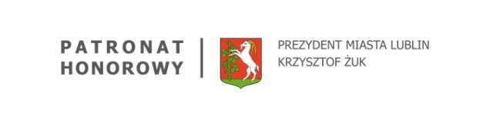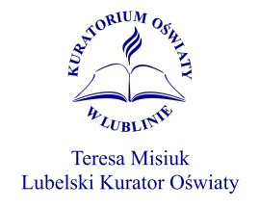

VIII INTERNATIONAL ENGLISH LANGUAGE and ART COMPETITION
“MY TOWN”
the Rules

The Organisers
- The Faculty of Humanities of the John Paul II Catholic University of Lublin,
- ZSP No. 1 in Lublin.
The Objectives
- promoting the civilizational heritage of Europe, patriotic education, learning about Polish history and culture, including spiritual and material achievements;
- motivating students to expand their knowledge of English and knowledge about their own city and region;
developing creativity and young artistic talents and popularizing students' achievements;
- supporting the development of students' digital skills, with particular emphasis on critical analysis of information available on the Internet.
The Participants
- Primary school students in Poland and abroad.
The categories
Works will be assessed in two age categories:
- Category 1 – students aged 6-9,
- Category 2 – students aged 10-15.
The stages of the competition:
- The first school stage - announcing the competition in individual schools, collecting and selecting the best works and sending them to the address of the competition organizer;
- The second international stage - qualification by the organizer of works that meet the regulatory requirements, evaluation and awarding of prizes and distinctions.
The rules of participation
- Students create a project in English – an album called “My town”.
- The aim of the project is to present the students’ city or town in a written and graphical form.
- The album should contain at least six A4 pages.
- Students design the layout in any painting techniques (gouache, acrylic, watercolor, dry or oil pastel, pencil, ink drawing, etc.) excluding collage and other cut and paste techniques (such as a tearing method of patchwork or cut-outs).
- The work should be performed individually. The works of multiple authors, rolled up or damaged will not be taken into consideration.
- A school participating in the competition may submit a maximum of four works to the international stage of the competition, taking into account both age categories.
- The projects should be delivered in person or sent by mail to the address of Zespół Szkolno-Przedszkolny No.1 in Lublin, postmarked no later than March 22, 2023.
- The cost of the delivery is covered by the sender.
- Together with the project, each contestant has to submit a filled-in Participation Card.
- The works are assessed by the competition committee, whose decisions are final.
- The assessment criteria: the content and language correctness, layout and originality.
- The organizers provide prizes and honorary mentions in both categories.
- Works submitted to the competition are not returnable and remain at the organizer's disposal.
- The competition results will be announced in April 2024. The list of winners will be published on the school website no later than April 22, 2024. The winners and distinguished winners will be notified by e-mail or telephone.
- The organizer reserves the right to delay the deadlines for deciding the competition, informing the winning students and handing out the prizes in the event of external difficulties that are not the fault of the organizer.
- Submissions of work to MY TOWN competition is equivalent with the acceptance of the contest regulations. Additionally, participation in the competition is equivalent to expressing consent to have one’s work presented and reproduced using personal data included in the Participant’s Card.

If you have any questions do not hesitate to contact us:

ewabaciur@wp.pl
Competition coordinator
Ewa Baciur

